**Republic of the Philippines**

**Nueva Ecija University of Science and Technology**

**General Tinio (Papaya)**

**QR Code Attendance Monitoring with Class Scheduling Management System**

**(For School Employees Only)**

**(QRAMSMS)**

**Submitted by:**

**Francis D. Caraang  
Chiara Alyssa T. Abesamis**

**In partial Fulfillment  
Of the Requirements for the Degree of  
Bachelor of Science in Information Technology  
With Specialization in Web Application Programming**

**CHAPTER I**

**INTRODUCTION**

The Bago Elementary School is dedicated to providing its employees with an efficient and modern system to monitor attendance and manage class schedules. One of the primary challenges faced by the school is the manual process of tracking employee attendance and coordinating class schedules. To address these issues, the school intends to implement a QR Code Attendance Monitoring with Class Scheduling Management System.

To meet this challenge, we propose the development of a web-based QR Code Attendance Monitoring with Class Scheduling Management System (QRAMSMS) designed to automate attendance monitoring and streamline class scheduling for school employees. The QRAMSMS system will utilize QR code technology to capture attendance in real-time, eliminating the need for manual data entry and reducing the risk of errors. Additionally, the system will feature a robust scheduling module to enable employees to manage their class schedules efficiently.

QRAMSMS will provide several benefits to Bago Elementary School, including improved accuracy in attendance monitoring, reduced administrative workload, enhanced transparency in class scheduling, and improved communication between employees and the school administration. The system will also empower the school administration to generate reports on attendance and scheduling, enabling data-driven decisions to enhance overall operational efficiency.

In summary, the proposed QRAMSMS system aims to modernize the attendance monitoring and class scheduling processes for school employees at Bago Elementary School. It will provide a user-friendly and efficient platform, replacing manual processes with QR code technology to ensure accurate attendance tracking and streamlined scheduling, ultimately contributing to the smooth operation of the school's employee activities.

The purpose of the "QR Code Attendance Monitoring with Class Scheduling Management System" is to provide Bago Elementary School with a state-of-the-art, web-based system that simplifies the task of monitoring employee attendance and managing class schedules. By introducing QR code technology, this system ensures more accurate attendance records than manual methods, while the scheduling management feature assists the school administration in efficiently organizing class schedules for school employees. Ultimately, this system aims to enhance the overall efficiency and productivity of Bago Elementary School, benefiting both employees and the institution as a whole.

The QR Code Attendance Monitoring with Class Scheduling Management System is a web-based software designed to assist the administration of Bago Elementary School in monitoring employee attendance and managing class schedules. The system leverages QR code technology to accurately record and monitor employee attendance in real-time. This feature eliminates the errors associated with manual processes and simplifies the task of attendance monitoring for the school administration.

Furthermore, the system includes a class scheduling management feature that empowers employees to efficiently manage their class schedules. This feature allows employees to schedule classes, manage availability, and coordinate class assignments, ensuring the smooth operation of their activities within the school.

The QR Code Attendance Monitoring with Class Scheduling Management System is designed to be user-friendly and intuitive, making it easy for school employees and administrators to use. With this system in place, the school administration can focus on more critical tasks, such as optimizing employee efficiency and ensuring a positive work environment. Overall, this system aims to help Bago Elementary School become more efficient and productive in managing its employee-related operations, ultimately benefiting both the employees and the institution.

**REVIEW OF RELATED LITERATURE AND SYSTEMS**

**RELATED LITERATURE**

The QR Code-Based Attendance Monitoring and Class Scheduling Management System is a software application that leverages QR code technology to accurately monitor faculty members' attendance and streamline class scheduling. It aims to replace manual attendance tracking systems with an automated solution. Research conducted by Wei and Manori in 2022 has shown that using QR code technology can significantly enhance educational efficiency by simplifying attendance management (Wei et al., 2017).

Furthermore, Chen and Liu's case study in 2023 demonstrates the successful integration of QR codes into campus systems for more efficient student attendance tracking (Chen & Liu, 2023). These studies underscore the growing importance of QR code technology in education and attendance management, indicating its potential to revolutionize traditional systems and improve administrative processes across educational institutions.

According to Labuanan et al., (2019), the scheduling of classes has been one of the most important factors that a school needs to prepare for before enrolment plays a vital role. The Class Scheduling System is a piece of software that enhances these procedures and offers a database for keeping records and data. In case of changes, it enables the end-user to add, edit, delete, save, and update records or information (Abdullah & Younus Abdullah, n.d.).

**RELATED SYSTEMS**

The system is highly relevant to educational institutions, especially those with a large faculty and student population. The software can save time and resources, provide accurate data on attendance, and streamline the scheduling process. It is also beneficial for institutions that prioritize safety and security by ensuring that only authorized personnel can access the campus.

According to (Wei et al., 2017), a QR code attendance monitoring system is a valuable tool for businesses to track and manage employee attendance. Unlike biometric systems that rely on physical traits such as fingerprints or iris scans, QR code attendance monitoring provides a more accessible and versatile approach to attendance tracking. This technology offers benefits such as improved accuracy, reduced time theft, and enhanced security in the workplace. A schedule is a plan that enumerates your tasks to assist you in setting priorities and achieving your objectives. A schedule describes an employee's workdays and hours in a professional setting. It contains details like the employees' names, working schedules, and tasks or responsibilities for that time frame (*Importance of Scheduling Tasks and Its Benefits | Profit.Co*, n.d.).

In the realm of attendance monitoring, the utilization of QR codes has emerged as an innovative approach. Unlike traditional attendance monitoring methods, QR code-based systems offer a more versatile and accessible means of tracking attendance. When individuals scan the QR code with their mobile devices, their attendance is accurately recorded (QR Code Attendance Tracking for Businesses and Classrooms | The Jotform Blog, n.d.).

Several human and automated tracking strategies have been proposed to address the problem of monitoring attendance for employees and users. However, these approaches have encountered various issues and challenges. For example, some methods, such as manual recording or sign-in sheets, have been found to be unreliable and prone to errors (Sarangi et al., 2021). On the other hand, the use of technology-based attendance tracking has also raised ethical concerns related to employee monitoring and data privacy (Facca et al., 2020). Despite these issues, researchers have continued to explore different approaches to ensure accurate and efficient attendance tracking for organizations.

Class scheduling is a crucial task for educational institutions, and both manual and automated methods have been developed to support this process. Automated systems, such as the Class Scheduling System (CSS), have been designed to improve the efficiency and accuracy of scheduling by providing a centralized database for storing and managing scheduling data (Labuanan et al., 2019). However, the adoption and use of such systems can also present various challenges and problems. One common issue is the need for continuous updates and modifications to the system to reflect changes in course offerings, faculty availability, and student demand (Abdullah & Younus Abdullah, n.d.). This requires ongoing maintenance and support, which can be time-consuming and resource-intensive. In addition, the use of technology can introduce new complexities and barriers, such as the need for specialized skills and training among users and the risk of technical failures or glitches(Kumar et al., 2019). Furthermore, the implementation of automated systems can also face resistance or skepticism from stakeholders who may prefer manual processes or have concerns about the reliability and security of the system ((Kim & Lee, 2020). Therefore, it is important for educational institutions to carefully consider these challenges and develop strategies to address them to ensure the successful implementation and use of automated scheduling systems.

Several software applications related to the proposed system have been developed. The following are software applications that have been developed for attendance tracking:

1. **Attendance QR Code System for Organizations**: The study intended a solution to deal with a difficulty with recording attendance after the technology. The suggested system is an application that uses QR codes to track employee attendance. Employees must scan their unique QR code to verify their attendance (Zarra & Bakashwean, 2023).
2. **Employee Attendance System Using QR Code**: The system is designed to revolutionize the conventional employee attendance tracking methods. This system leverages the power of Quick Response (QR) codes to create a seamless and efficient attendance management solution for organizations (Employee Attendance System Using QR Code - JP INFOTECH, n.d.).
3. **Employee Attendance System By QR Scan**: This project is designed to take down employees’ attendance using Qr code. Every employee will be having a card that contains a unique Qr code. Each Qr code represents a unique id for all employees. They just have to scan their cards in front of the webcam on arriving and the system notes down their attendance as per date and time. System then stores all the employees’ attendance records. It generates an overall report in excel sheet for admin and even allows him to search for particular employees attendance (Employee Attendance System By Qr Scan Project, n.d.).
4. **RealSoft** **Attendance**: This software offers biometric attendance tracking using fingerprint and face recognition. It has features such as automatic shift scheduling, real-time monitoring, and reporting(*Softwares | Realtime Biometrics | India’s Leading Biometrics Company*, n.d.).

Some of the different software developed for class scheduling are as follows:

1. **CollegeNET**: This is a cloud-based scheduling software that allows educational institutions to create, manage and share class schedules. It provides real-time updates, conflict resolution, and automated scheduling tools to enhance the scheduling process (*CollegeNET - Serving Higher Ed Admissions, Scheduling & More!*, n.d.).
2. **Schedule360**: This software is designed specifically for healthcare institutions and offers advanced scheduling features such as shift-swapping, self-scheduling, and real-time communication (*Nurse Scheduling Software | Healthcare Scheduling Software*, n.d.).
3. **Coursedog**: This software is designed for higher education institutions and offers scheduling, curriculum management, and registration tools. It provides real-time updates, drag-and-drop scheduling, and automated conflict resolution (*Coursedog | Integrated Academic Operations Platform*, n.d.).
4. **SubItUp**: This software is a scheduling and employee management tool that offers features such as shift-swapping, automated scheduling, and real-time updates. It is suitable for educational institutions as well as other industries (*Workforce Management Solutions | SubItUp*, n.d.).

**SYNTHESIS**

In the realm of educational administration, the integration of cutting-edge technology is reshaping attendance monitoring and class scheduling practices. The QR Code Attendance Monitoring with Class Scheduling Management System emerges as a pivotal innovation, capitalizing on Qr code technology to enhance accuracy and security. As revealed by Mohamed & Raghu (2012), the incorporation of automated fingerprint recognition underscores the commitment to reliability, even as initial detection challenges are acknowledged. However, the widespread adoption of technology-based attendance tracking systems also raises concerns about privacy, as noted by Facca et al. (2020), necessitating a balance between technological advancement and ethical considerations.

**CONCEPTUAL FRAMEWORK**  
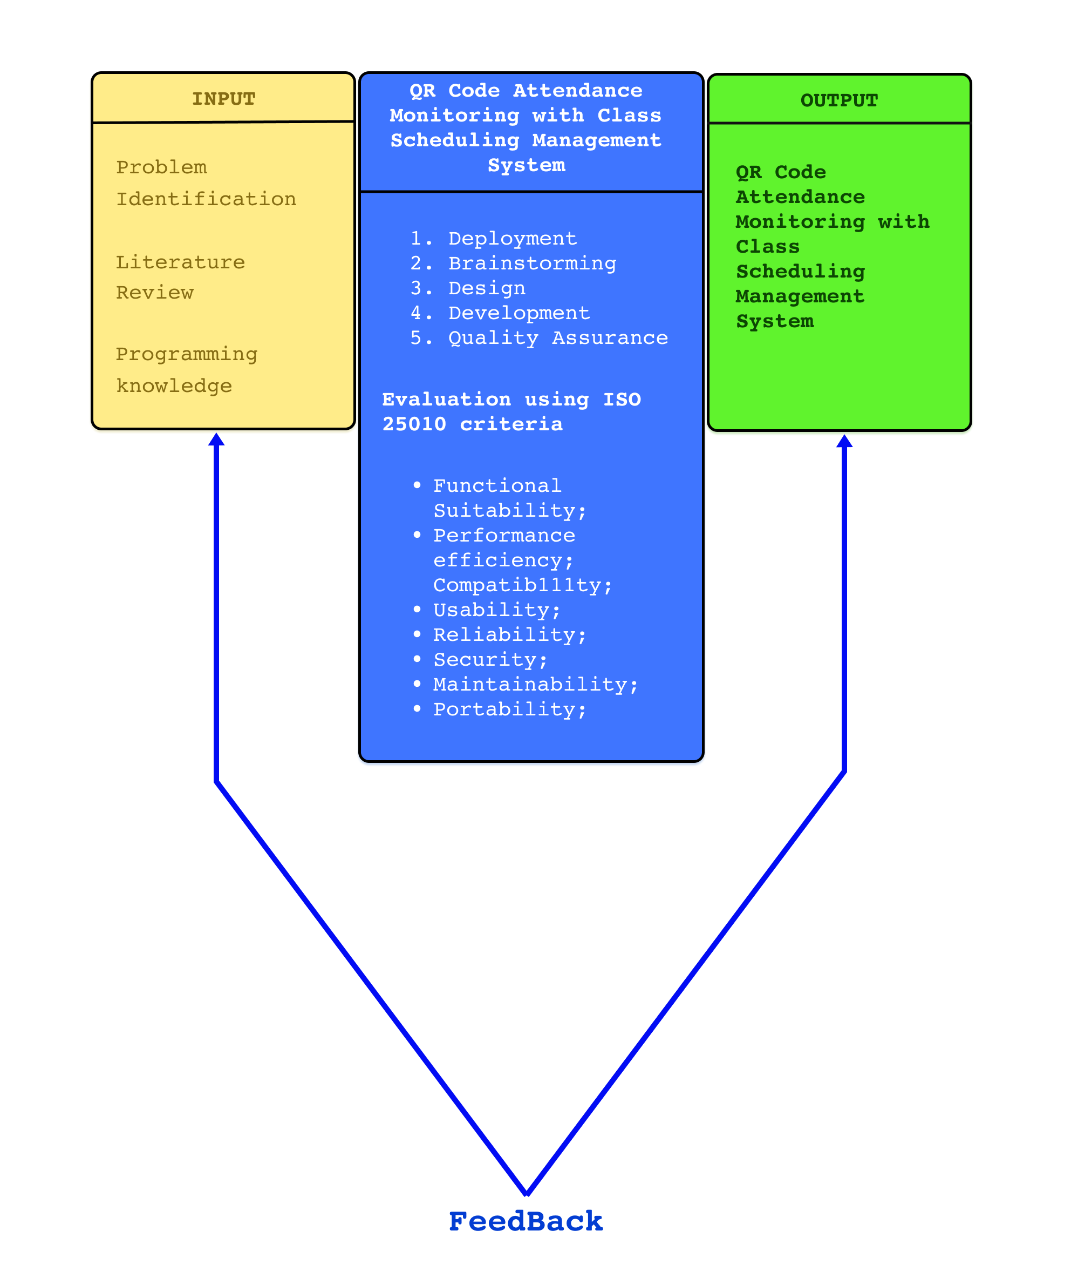

Fig. 1. Conceptual Framework: QR Code-Based Attendance Monitoring with Scheduling Management System (QRAMSMS)

As shown in Figure 1, the input comprises problem identification, literature review, and programming knowledge. First, problem identification: the respondents to this study will be the school employees and staff. There are so many employees of the school who want to ease the process of monitoring employee attendance and managing class schedules.

The researchers have an opportunity to propose a solution by developing a system to monitor the employee attendance and managing class schedules. The researchers performed research on various literatures and related system to serve as an outline in their development of the monitoring employee attendance and managing class schedules in (name of the school) for the literature study.

And last, programming knowledge: at this point, the researchers can build and develop the system using their programming expertise. The procedure involves collecting requirements, designing and building, testing, assurance, deployment, and feedback. The agile model that will be utilized when developing the system is described in the framework.

When each step has been properly finished. The QR Code Attendance Monitoring with Class Scheduling Management System in Bago Elementary School assists faculty and staff in recording, retrieving, and tracking their attendance as well as managing the process of creating class schedules.

**STATEMENT OF THE PROBLEM**

Bago Elementary School is currently grappling with a significant challenge: accurately monitoring employee attendance and efficiently managing class schedules for its workforce. The existing method of attendance tracking relies on a manual process, leading to inaccuracies and inefficiencies. To tackle these issues effectively, the school has embarked on a mission to implement a cutting-edge solution—a web-based QR Code Attendance Monitoring with Class Scheduling Management System (QRAMSMS).

The proposed system is designed to harness QR code technology to capture real-time attendance data, thus improving accuracy while eliminating the risk of manual data entry errors. Additionally, the system will include a scheduling management module that empowers school employees to effectively manage their class schedules, optimizing classroom usage and employee allocation.

The primary challenge lies in the current inefficiencies and inaccuracies associated with manual attendance tracking and class scheduling. These challenges impede the school's ability to streamline administrative processes, allocate resources efficiently, and foster effective communication with its employees. Therefore, the development of the QRAMS system aims to overcome these limitations and provide a comprehensive solution that enhances the overall efficiency of Bago Elementary School's administrative operations.

**SCOPE AND LIMITATIONS**

**Scope:**

* The capstone project will focus on the development of a QR Code Attendance Monitoring with Class Scheduling Management System tailored for school employees.
* The system will rely on QR code technology to monitor employee attendance in real-time, eliminating manual attendance records and enhancing accuracy.
* A key component of the system will be the inclusion of a class scheduling management module, facilitating efficient employee class scheduling, optimal classroom allocation, and reducing scheduling conflicts.
* The system's design will prioritize user-friendliness to ensure ease of operation.

**Limitations:**

* The project will not involve the creation of proprietary hardware for generating QR codes or scanning attendance. Instead, it will utilize existing QR code generation and scanning tools available in the market.
* The project will not encompass the integration of the system with other existing school systems, such as the student information system or payroll system.
* Data privacy and security aspects will not be thoroughly addressed within the project's scope. However, the system will be designed to comply with standard data protection regulations to safeguard sensitive information.
* Ongoing system maintenance and support beyond the completion of the capstone project will not be included. The project will focus on the initial development and testing phases.

**Significance of the Study**

The proposed "QR Code Attendance Monitoring with Class Scheduling Management System" carries substantial significance for Bago Elementary School and its stakeholders. This study aims to deliver a comprehensive and contemporary solution that harnesses QR code technology to streamline attendance monitoring and class scheduling management, addressing critical challenges faced by the school administration.

**Improved Accuracy and Efficiency:** The introduction of QR code technology ensures real-time, accurate attendance tracking, eliminating the inaccuracies associated with manual data entry. This heightened precision extends to efficient management of employee class schedules, leading to optimized classroom usage and effective allocation of teaching resources.

**Reduced Administrative Workload:** By automating the attendance monitoring process and centralizing scheduling management, the proposed system reduces the administrative burden on school staff. This allows administrators to allocate their time and effort more effectively toward other critical tasks, such as enhancing the overall quality of education.

**Enhanced Transparency and Communication:** The proposed system promotes transparency between faculty members and the school administration by providing a platform that displays accurate attendance records and class schedules. This transparency fosters trust and clear communication between stakeholders, contributing to a harmonious academic environment.

**Data-Driven Decision Making:** With the ability to generate comprehensive reports on attendance and scheduling, the school administration gains access to valuable data for informed decision making. These insights can be instrumental in identifying patterns, optimizing resource allocation, and enhancing the overall operational efficiency of the school.

**Elevated Academic Performance:** The successful implementation of the proposed system can lead to improved academic outcomes. With faculty members having streamlined access to their schedules and administrative tasks, they can focus more on teaching and fostering a conducive learning environment, ultimately benefiting the students' educational experience.

**Contribution to Future Research:** The development and implementation of the proposed system contribute to the growing body of research in educational technology and administration. Future researchers can build upon the methodology, insights, and technical aspects of this study to explore further enhancements or adaptations of the system for different educational institutions or specific use cases.

**Experiential Learning for Researchers:** The researchers engaged in this study stand to gain valuable experiential learning opportunities. They will acquire hands-on experience in designing, developing, and implementing a complex software solution tailored to a real-world problem. This experience equips them with practical skills in project management, software development, user interface design, and collaboration.

In conclusion, the "QR Code Attendance Monitoring with Class Scheduling Management System" represents a pivotal advancement for Bago Elementary School and its stakeholders. By harnessing the power of QR code technology, this study offers a transformative solution that not only addresses immediate challenges but also lays the groundwork for a more efficient, transparent, and data-driven educational work environment. The significance of this study lies not only in its potential to streamline administrative processes but also in its contribution to the broader field of educational technology research. As the proposed system is embraced and refined, it has the capacity to elevate workforce performance, enhance communication, and empower administrators and employees alike. This endeavor not only benefits the present but also lays the foundation for a more innovative and responsive educational landscape in the future.

**DEFINITION OF TERMS**

In the context of this study, the following terms are presented with their respective definitions to ensure clarity and comprehension:

**QR Code**: A QR code (Quick Response code) is a two-dimensional barcode that can be scanned with a smartphone or a dedicated QR code scanner. In this context, it's used to record and monitor employee attendance in real-time.

**Web-based System**: This refers to a software application that operates through a web browser, making it accessible on the internet without the need for installation on individual devices.

**Attendance Monitoring**: This is the process of keeping track of when employees or individuals are present or absent. In this case, it is being automated using technology to reduce errors.

**Class Scheduling**: This is the arrangement of class or work hours for employees or students. It includes deciding when and where classes will be held, which teachers or employees will be responsible, and what subjects or tasks will be covered.

**QRAMSMS** (QR Code Attendance Monitoring with Class Scheduling Management System): This is the acronym for the software being developed. It combines QR code technology for attendance tracking and class scheduling management.

**User-Friendly**: This means that the system is easy to use for individuals, even those who are not technology experts.

**Administrative Workload**: The tasks and responsibilities related to managing the day-to-day operations of the school, including attendance tracking and scheduling.

**Transparency**: The quality of being clear and open in communication and operations, ensuring that everyone involved understands what is happening.

**Data-Driven Decisions**: Making choices based on collected information and statistics rather than intuition or tradition.

**Educational Efficiency**: The ability to improve how the school functions, resulting in better outcomes for both employees and students.

**Privacy and Security**: Protecting sensitive information and ensuring that unauthorized individuals cannot access data.

**Experiential Learning**: Learning by doing, gaining practical experience by working on a real-world project.

**Software Application**: A computer program designed to perform specific tasks, such as attendance tracking and scheduling management.

**Manual Process**: Traditional methods that require physical effort and often involve paperwork.

**Real-Time**: Happening immediately or with minimal delay, as opposed to batch processing where data is collected and processed later.

**Conflict Resolution**: The process of managing and resolving scheduling conflicts, ensuring that employees or students are not double-booked.

**Automated Scheduling**: Using technology to create and manage schedules without manual intervention.

**Cloud-Based**: Software or services that are hosted on the internet, allowing access from anywhere with an internet connection.

**CHAPTER II**

**METHODOLOGY**

This chapter presents the research design, study location, study respondents, sampling procedure, research instrument, data gathering procedure, and data analysis technique.

**RESEARCH DESIGN**

Developmental research is a type of study that was utilized to create QR Code Attendance Monitoring with Class Scheduling Management System.

Developmental research is defined as the scientific study of creating, producing, and assessing instructional programs, procedures, and products that must meet internal consistency and effectiveness requirements. This is distinct from simple instructional development, which is simply the act of ensuring that what is taught works. Developmental research was appropriate for system design and development.

Furthermore, in order to get input and make changes that made the generated program usable, the researchers a quantitative research survey was used. A survey is a research technique used to collect data from a predetermined group of respondents in order to get information and insights on a variety of topics of interest.

**Locale of the Study**

The researchers conducted the study at Bago Elementary School wherein the researchers were affiliated with the institution.

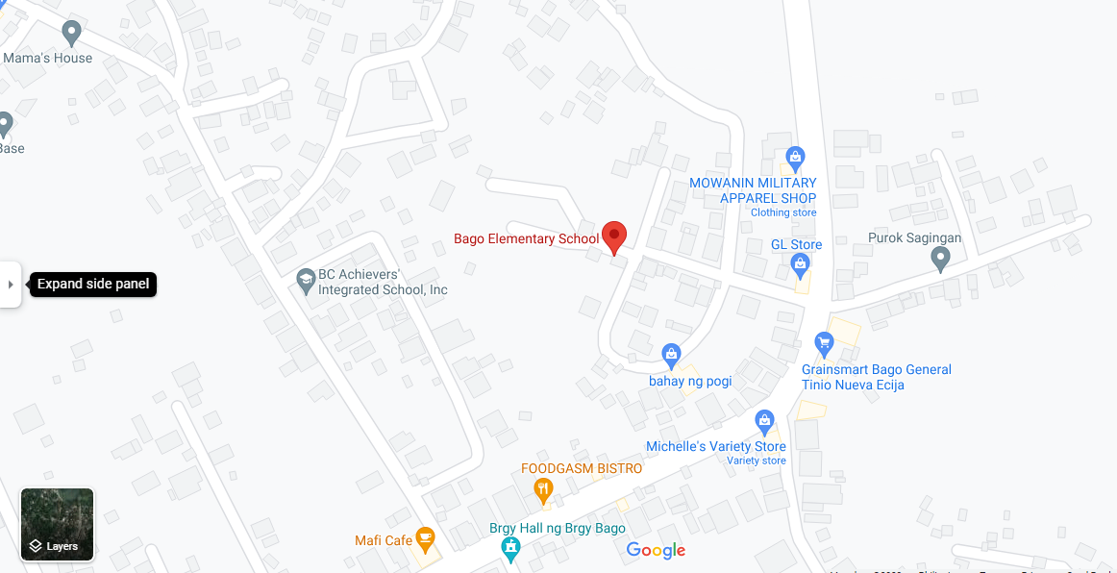Figure 2 shows the map of Bago Elementary School

**Respondents of the study**

The respondents for this study will consist of various individuals associated with Bago Elementary School. Firstly, school administrators, comprising the principal, vice-principal, and administrative staff, will be included to gauge their perspectives on the QRAMSMS implementation's impact on school operations. Secondly, teachers will form a crucial part of the sample as they will be using the system to manage class schedules and attendance records.

Additionally, non-teaching staff members, including administrative personnel, clerks, and others involved in administrative tasks, will provide insights into the system's effect on their daily responsibilities. IT staff, responsible for implementing and maintaining the QRAMSMS system, will offer their expertise. This comprehensive set of respondents will enable a holistic evaluation of the QRAMSMS system's implementation at Bago Elementary School.

**Sample and Sampling Procedure**

The selection of responses in this Purposive research will be determined by the researchers conducting the sampling process. Purposive sampling is a methodology in which non-probability sampling is employed. In this approach to research, researchers exercise their own judgment to determine which individuals from the population should participate in their surveys. It involves the use of specific criteria to carefully choose suitable respondents who can provide meaningful insights for the study.

Furthermore, this method goes beyond random selection and aims to select individuals who possess characteristics or knowledge relevant to the research objectives. This approach is valuable when researchers seek to target specific expertise, experiences, or perspectives within a population. By employing purposive sampling, researchers can enhance the quality and relevance of their data, ultimately leading to more robust and insightful research findings.

**Research Instrument**

This investigation was carried out using an manual survey questionnaire, which is organized research that the target audience fills out on the manual paper. The researchers used hard copy as a survey platform.

Furthermore, a questionnaire was used as the research tool in this study. A questionnaire is a collection of research or survey questions. Questions posed to respondents in order to gather precise information that will be used to collect relevant data and make it available for analysis. The manual survey questionnaire employed ordinal as a rating system of variables on the Likert items to measure the responses of the respondents.

The research instrument was based on the study's problem statement, which has three (3) parts. The first part the system's design was identified and developed using the agile model's stages. The second part described how IT specialists evaluated the system's technical aspects using ISO 25010 criteria. The last part determined how the end user believes the system works.

**Data Gathering Procedure**

The researchers' first task was to get authorization from their research adviser to conduct such a survey for the study, before handing over the respondent's authorization Check out the site and the questionnaire. After the system was then tested by the responders that participated in the manual survey to participate in the survey, fill out on the questionnaire survey. The Researchers were prepared to resolve any issues that occurred, additional issues or questions expressed by the respondents.

**Data Analysis**

To gain a deeper understanding of the study's results, the researchers employed various analytical techniques, including verbal interpretation, calculation of means, and determination of percentages based on the responses provided by the study participants. These analytical approaches were instrumental in dissecting and comprehending the data collected during the research process.

In their quest to explore the study's findings in greater detail, the researchers utilized verbal interpretation, which involved carefully analyzing and interpreting the participants' responses in a qualitative manner. This allowed them to extract nuanced insights and identify recurring themes or patterns within the data. Additionally, mean calculations were used to derive numerical summaries that provided a quantitative perspective on the central tendencies of the responses. By calculating percentages, the researchers were able to gauge the prevalence or distribution of specific responses or variables, offering a valuable perspective on the data's composition.

In summary, the researchers employed a multifaceted approach, encompassing both qualitative and quantitative methods, to delve deeper into the study's findings. This comprehensive analysis allowed for a more thorough exploration of the data and contributed to a richer understanding of the research outcomes.

**CHAPTER III**

**RESULTS AND DISCUSSION**

This chapter demonstrates the progress and assessment of the QR Code Attendance Monitoring with Class Scheduling Management System based on data gathered from a questionnaire conducted at Bago Elementary School. Respondents in this study were categorized into two main classifications: IT professionals and end users. Following the ISO 25010 software quality standards, these professionals and end users were requested to evaluate the technical quality of the QR Code Attendance Monitoring with Class Scheduling Management System.

1. **Development of the QR Code Attendance Monitoring with Class Scheduling Management System based on the phases of the stages of Agile Model.**

The development of the QR Code Attendance Monitoring with Class Scheduling Management System went through the six (6) stages of the Agile Model as describe below.

**Requirements Analysis Stage**

The researchers performed a variety of tasks, such as observations, brainstorming, and interviews. Their aim was to create a strategy for how the developed system should integrate with the existing processes and provide solutions to the problems faced by the researchers. Additionally, they developed a Gantt chart outlining the different stages of the Agile Model to serve as a guide for the construction of the system.

**Gantt Chart**

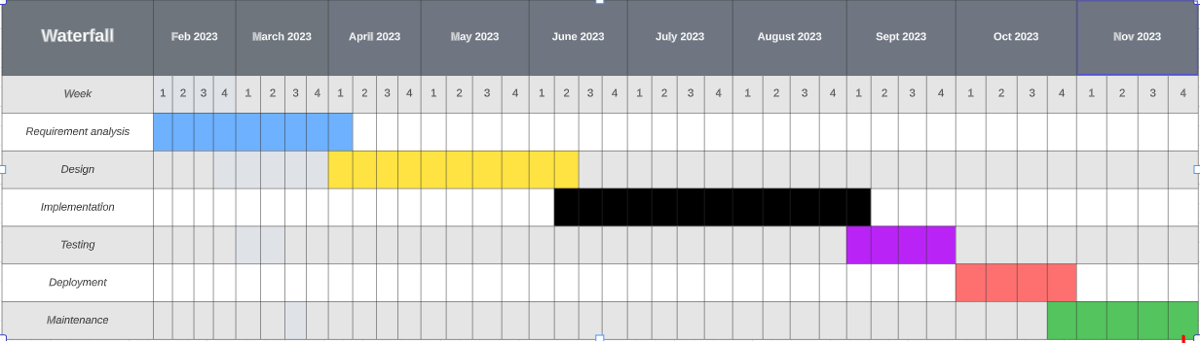Figure 3 shows the schedule of activities that the researchers underwent during the course of development of the QR Code Attendance Monitoring with Class Scheduling Management System.

**Fig. 3.**Gantt chart of Activities

**Design Stage**

In this crucial phase of our research journey, our dedicated team of researchers diligently crafted a series of straightforward diagrams. Our primary objective during this endeavor was to attain a profound and comprehensive understanding of the pivotal activities and processes intrinsic to the system we had painstakingly developed.

Through the creation of these diagrams, our aim was to uncover the intricate details and interconnections within the system, thus facilitating a holistic perspective of its functionality. This in-depth analysis would, in turn, empower us to make informed decisions and identify opportunities for enhancement. Our commitment to meticulousness and thoroughness in our examination left no aspect of the system unexplored. This dedication underscored our unwavering pursuit of excellence in research and the continuous improvement of our system.

**Data Flow Diagram**

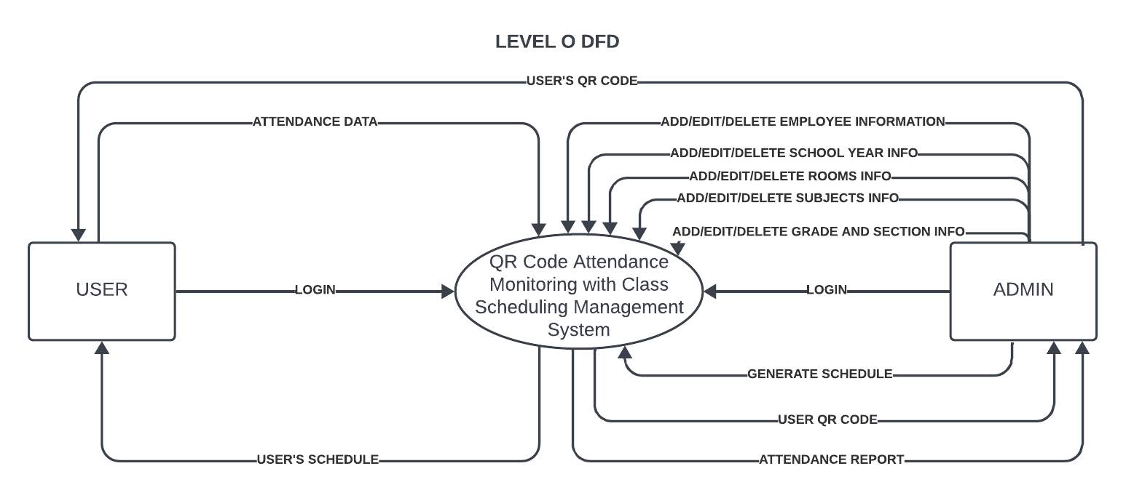

Figure 4 presents the context diagram for the developed system, outlining external entities and the processes encapsulated within the QR Code Attendance Monitoring with Class Scheduling Management System.

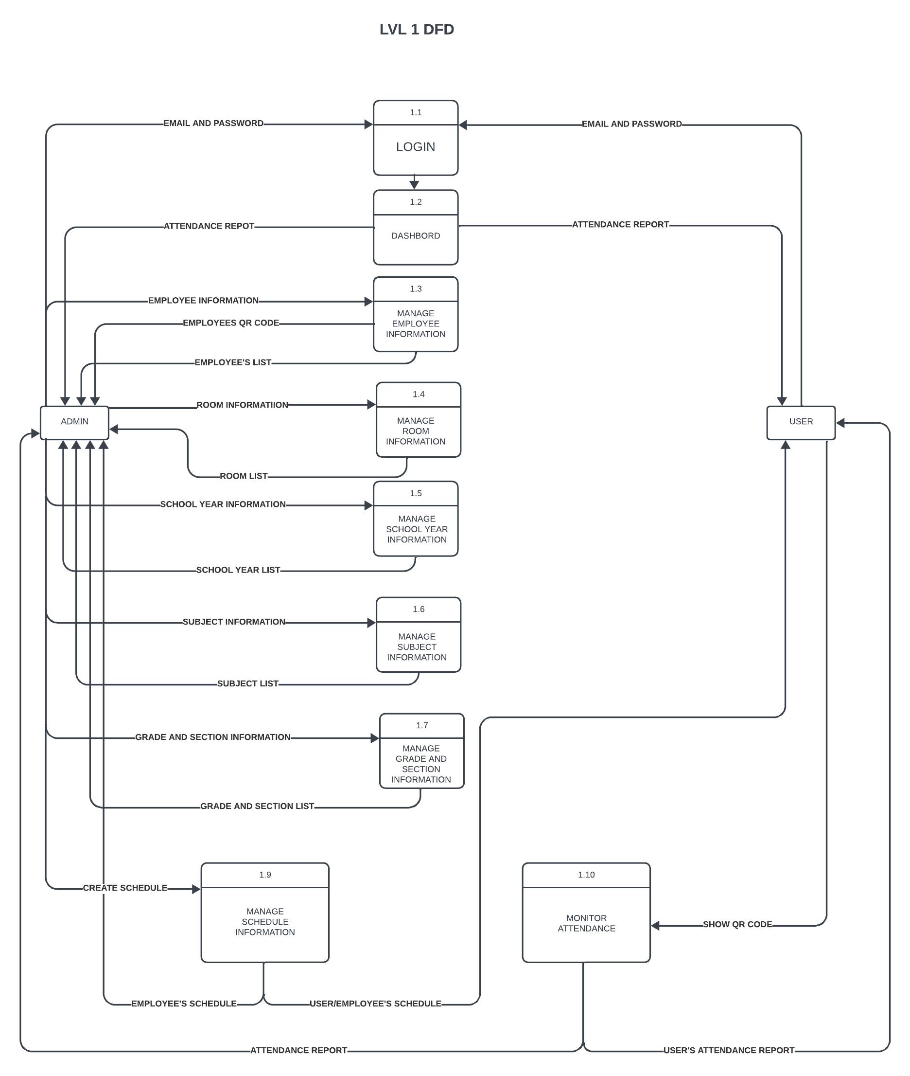

Figure 5 shows the level 1 representation of the data flow diagram. It has 2 entities, user and admin.

**Use-case Diagram**

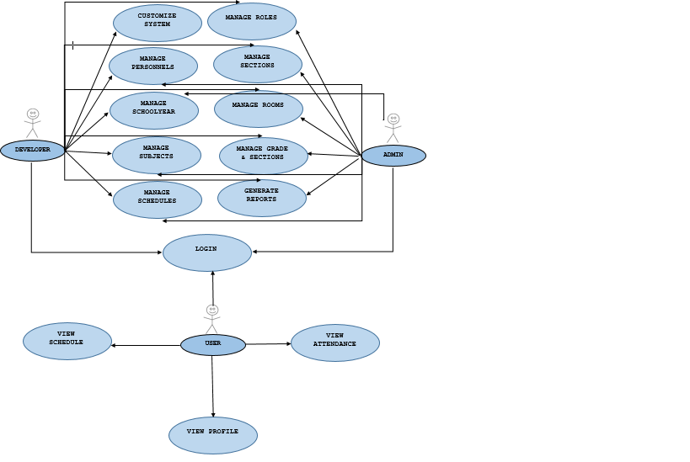

**HIPO Chart**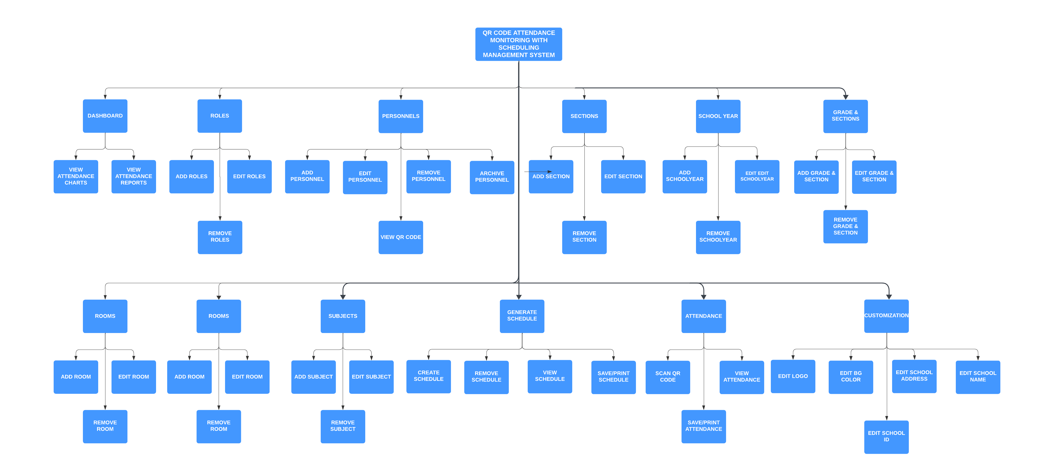

Figure 7 shows hipo chart of the developed system. It represents the programs control structure in QR Code Attendance Monitoring with Class Scheduling Management System.

**Entity-Relationship Diagram**

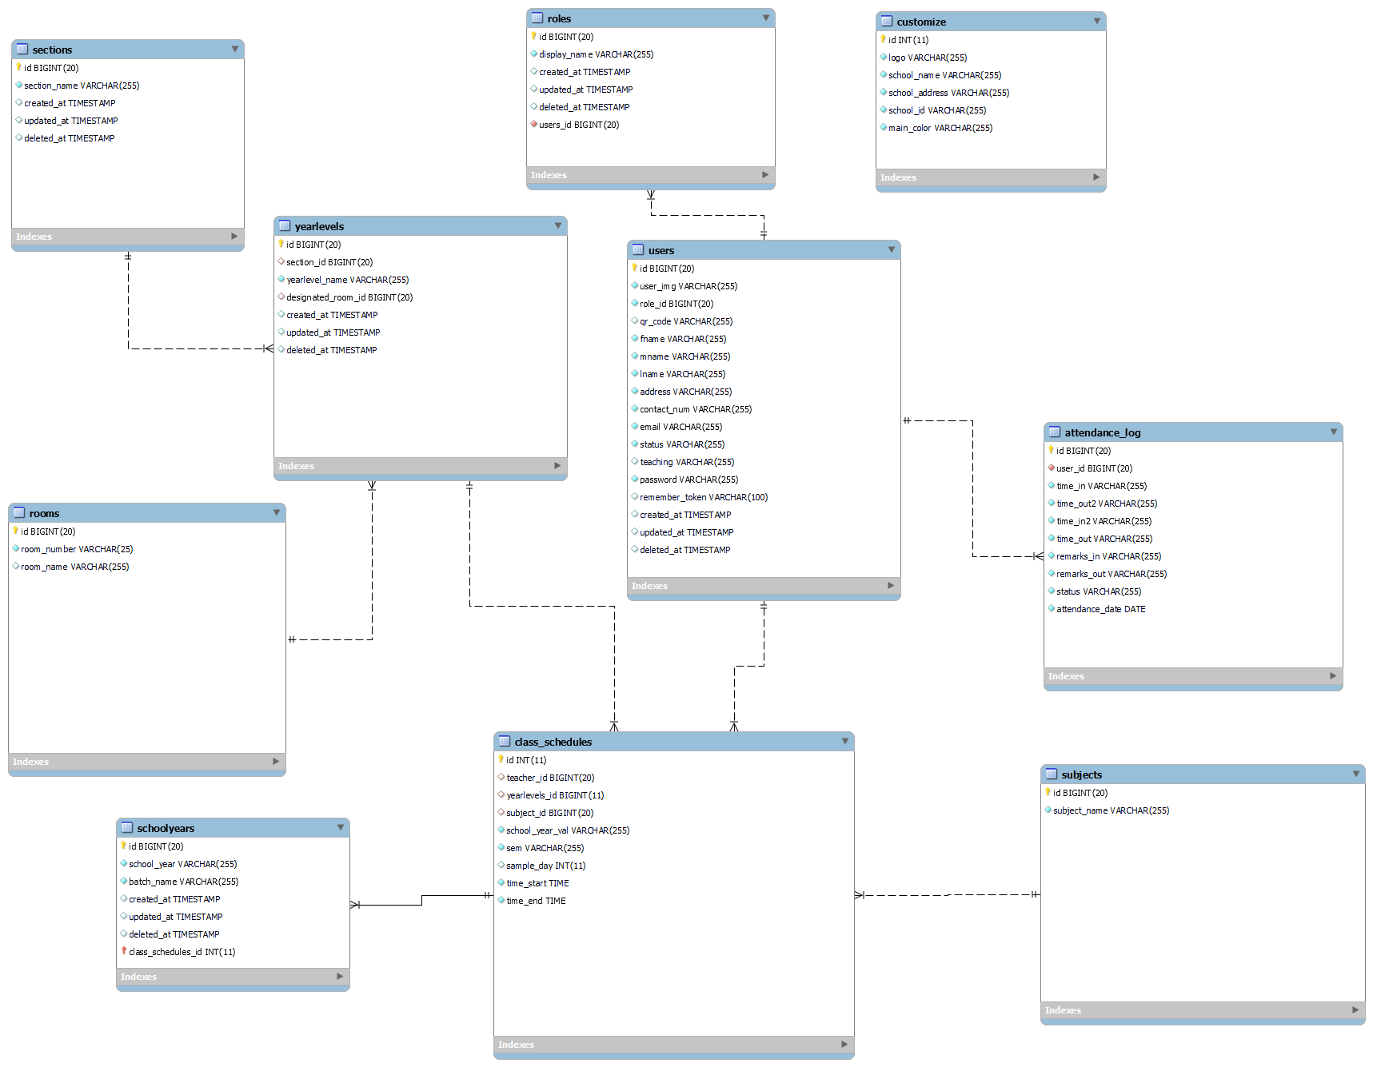

Figure 8 shows the ERD for a QR Code Attendance with Scheduling Management System requires a comprehensive understanding of the system's requirements, entities, relationships, and attributes.

**Database Normalization**

**pictureeeeeeee**

**Data Dictionary**

Data dictionary is a collection of descriptions of the data objects or items in a data model. It was made to enable other programmers to understand every entity belonging in a relation.

Figure 10 shows the data dictionary of the tables used to develop the QR Code Attendance Monitoring with Class Scheduling Management System.

**ATTENDANCE LOG**

|  |  |  |  |  |
| --- | --- | --- | --- | --- |
| **FIELD NAME** | **DATA TYPE** | **FIELD LENGTH** | **KEY** | **DESCRIPTION** |
| ID | BIG INT | 20 | PRIMARY | ATTENDANCE LOG ID, AUTO INCREMENT |
| USER_ID | BIG INT | 20 | FOREIGN | ID OF THE USER |
| TIME_IN | VARCHAR | 255 |  | USER TIME IN TIME |
| TIME_OUT2 | VARCHAR | 255 |  | USER AFTERNOON TIME OUT |
| TIME_IN2 | VARCHAR | 255 |  | USER AFTERNOON TIME IN |
| TIME_OUT | VARCHAR | 255 |  | USER TIME OUT |
| REMARKS_IN | VARCHAR | 255 |  | TIME IN REMARKS |
| REMARKS OUT | VARCHAR | 255 |  | TIME OUT REMARKS |
| STATUS | VARCHAR | 255 |  | USER ATTENDANCE STATUS |
| ATTENDANCE_DATE | DATE |  |  | ATTENDANCE LOG DATE |

**CLASS SCHEDULES**

|  |  |  |  |  |
| --- | --- | --- | --- | --- |
| **FIELD NAME** | **DATA TYPE** | **FIELD LENGTH** | **KEY** | **DESCRIPTION** |
| ID | BIG INT | 20 | PRIMARY | ATTENDANCE LOG ID, AUTO INCREMENT |
| TEACHER_ID | BIG INT | 20 | FOREIGN | ID OF USER |
| YEARLEVELS_ID | BIG INT | 20 | FOREIGN | ID OF YEAR_LEVELS |
| SUBJECT_ID | BIG INT | 20 | FOREIGN | ID OF SUBJECTS |
| SCHOOL_YEAR_VAL | VARCHAR | 255 |  | SCHOOL YEAR |
| SEM | VARCHAR | 255 |  | SEMESTER |
| SAMPLE_DAY | INT | 11 |  | INDEX VALUE OF DAY |
| TIME_START | TIME |  |  | START TIME OF THE SCHEDULE |
| TIME_END | TIME |  |  | END TIME OF THE SCHEDULE |

**CUSTOMIZE**

|  |  |  |  |  |
| --- | --- | --- | --- | --- |
| **FIELD NAME** | **DATA TYPE** | **FIELD LENGTH** | **KEY** | **DESCRIPTION** |
| ID | INT | 11 | PRIMARY | ID OF CUSTOMIZE |
| LOGO | VARCHAR | 255 |  | SCHOOL LOGO |
| SCHOOL_NAME | VARCHAR | 255 |  | SCHOOL NAME |
| SCHOOL_ADDRESS | VARCHAR | 255 |  | SCHOOL ADDRESS |
| SCHOOL_ID | VARCHAR | 255 |  | SCHOOL ID |
| MAIN_COLOR | VARCHAR | 255 |  | BACKGROUND COLOR |

**ROLES**

|  |  |  |  |  |
| --- | --- | --- | --- | --- |
| **FIELD NAME** | **DATA TYPE** | **FIELD LENGTH** | **KEY** | **DESCRIPTION** |
| ID | BIGINT | 20 | PRIMARY | ID OF ROLES |
| DISPLAY_NAME | VARCHAR | 255 |  | ROLES DISPLAY NAME |

**ROOMS**

|  |  |  |  |  |
| --- | --- | --- | --- | --- |
| **FIELD NAME** | **DATA TYPE** | **FIELD LENGTH** | **KEY** | **DESCRIPTION** |
| ID | BIG_INT | 20 | PRIMARY | ID OF ROOMS |
| ROOM_NUMBER | VARCHAR | 255 |  | ROOM NUMBER |
| ROOM_NAME | VARCHAR | 255 |  | ROOM NAME |

**SCHOOLYEARS**

|  |  |  |  |  |
| --- | --- | --- | --- | --- |
| **FIELD NAME** | **DATA TYPE** | **FIELD LENGTH** | **KEY** | **DESCRIPTION** |
| ID | BIGINT | 20 | PRIMARY | ID OF SCHOOLYEARS |
| SCHOOL_YEAR | VARCHAR | 255 |  | SCHOOL YEAR |
| BATCH_NAME | VARCHAR | 255 |  | BATCH NAME |

**SECTIONS**

|  |  |  |  |  |
| --- | --- | --- | --- | --- |
| **FIELD NAME** | **DATA TYPE** | **FIELD LENGTH** | **KEY** | **DESCRIPTION** |
| ID | BIG_INT | 20 | PRIMARY | ID OF SECTIONS |
| SECTION_NAME | VARCHAR2 | 255 |  | SECTION NAME |

**SUBJECTS**

|  |  |  |  |  |
| --- | --- | --- | --- | --- |
| **FIELD NAME** | **DATA TYPE** | **FIELD LENGTH** | **KEY** | **DESCRIPTION** |
| ID | BIG_INT | 20 | PRIMARY | ID OF SECTIONS |
| SUBJECT_NAME | VARCHAR | 255 |  | SUBJECT NAME |

**YEARLEVELS**

|  |  |  |  |  |
| --- | --- | --- | --- | --- |
| **FIELD NAME** | **DATA TYPE** | **FIELD LENGTH** | **KEY** | **DESCRIPTION** |
| ID | BIG_INT | 20 | PRIMARY | ID OF YEARLEVELS |
| SECTION_ID | BIG_INT | 20 | FOREIGN KEY | ID OF SECTION |
| YEARLEVEL_NAME | VARCHAR | 255 |  | YEARLEVEL NAME |
| DESINATED_ROOM_ID | BIGINT | 20 | FOREIGN KEY | ID OF DESIGNATED ROOM |

**USERS**

|  |  |  |  |  |
| --- | --- | --- | --- | --- |
| **FIELD NAME** | **DATA TYPE** | **FIELD LENGTH** | **KEY** | **DESCRIPTION** |
| ID | BIG_INT | 20 | PRIMARY | ID OF YEARLEVELS |
| USER_IMG | VARCHAR | 255 |  | USER IMAGE |
| ROLE_ID | BIGINT | 20 | FOREIGN | ID OF ROLES |
| QR_CODE | VARCHAR | 255 |  | QR CODE |
| FNAME | VARCHAR | 255 |  | FIRST NAME |
| MNAME | VARCHAR | 255 |  | MIDDLE NAME |
| LNAME | VARCHAR | 255 |  | LAST NAME |
| ADDRESS | VARCHAR | 255 |  | ADDRESS |
| CONTACT_NUM | VARCHAR | 255 |  | CONTACT NUMBER |
| EMAIL | VARCHAR | 255 |  | EMAIL ADDRESS |
| STATUS | VARCHAR | 255 |  | STATUS |
| TEACHING | VARCHAR | 255 |  | IF USER IS TEACHING OR NOT |
| PASSWORD | VARCHAR | 255 |  | USER PASSWORD |

**Implementation Stage**

During this step, the researchers transformed the information collected during the design stage into a physical system. The actual code for the system was written using Visual Studio Code during the development phase. They also used PhpMyAdmin to create the database.

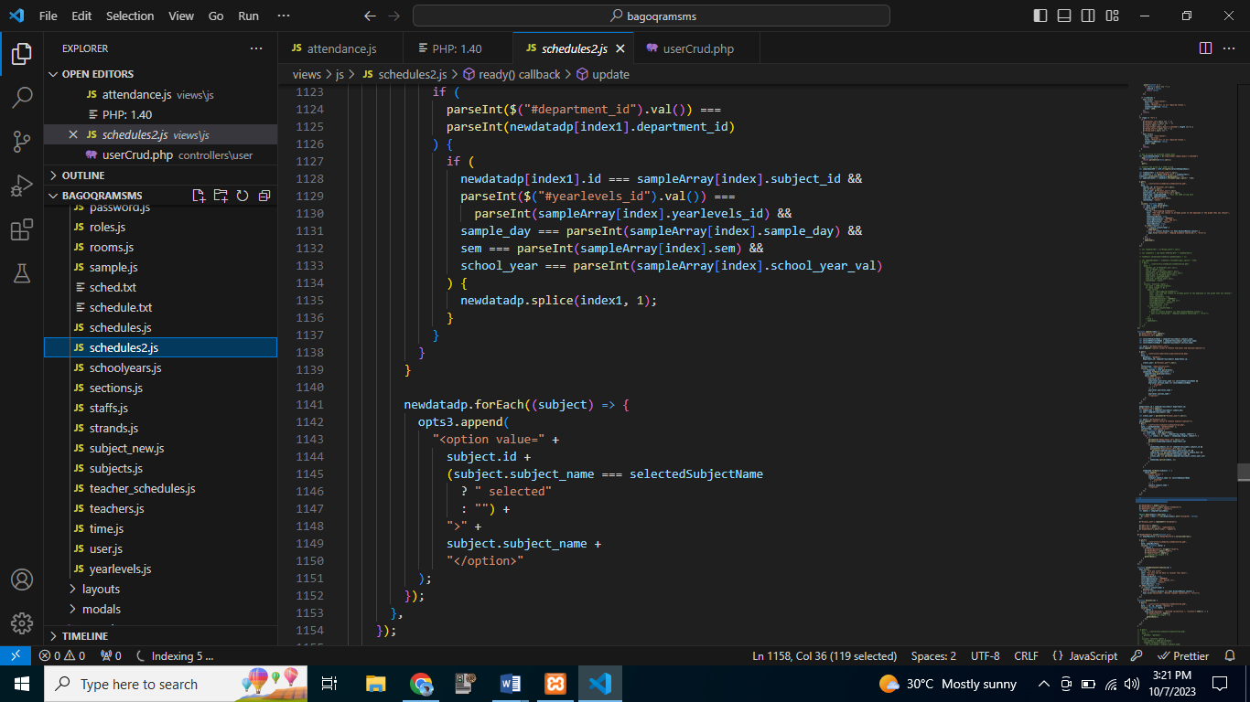

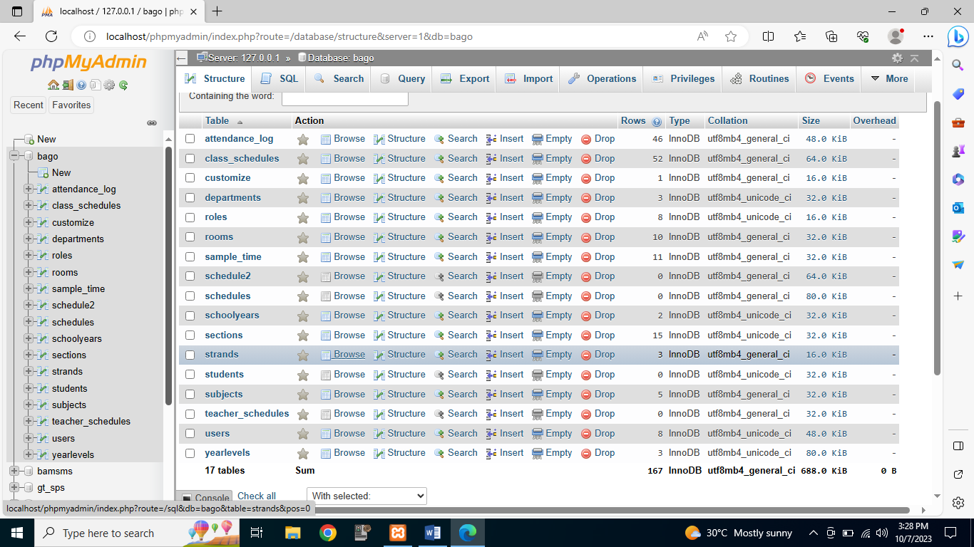

**Testing Stage**

At this point, the researchers employed functional testing to ensure that each function provided suitable input. Functional testing focuses on the system's primary functions, fundamental usability, accessibility, and error situations.

Mainline function testing involves researchers testing the system's primary functions to ensure that they are functioning properly. In basic usability testing, researchers study the system to see if the user can freely browse the screen and whether the buttons function properly.

The accessibility testing researchers examine the system to see if the user can browse the website without encountering any unknown system issues.

Lastly, the researchers evaluate the error situations to see if the error messages are displayed on the screen.

**Deployment Stage**

This stage of the agile model enabled the researchers to present the developed system to possible IT experts and the employees and staff of Bago Elementary School. In this phase, the researchers personally presented their proposed system and evaluated its technical aspects based on ISO 25010 standards.

**Maintenance Stage**

At this point, the researchers would like to do several forms of maintenance, such as corrective maintenance, adaptive maintenance, perfective maintenance, and preventive maintenance.

In corrective maintenance, researchers make improvements and updates to the system to solve issues discovered by users or other researchers.

The system will go through adaptive maintenance so that the researchers can make adjustments and upgrades to keep it current and functional with different browsers.

To maintain the system functional over a longer period of time, the researchers will implement changes and upgrades during preventive maintenance. The system will be enhanced through the addition of new features that can increase functionality, make the user experience better, and make the system run more quickly.

The final step is preventative maintenance, in which the researchers will make changes and updates to the system to guard against potential future problems. It aims to address minor issues that could grow into large issues later. The researchers will recreate the code to make it easier to understand and to optimize it for faster program performance.

Assessment on the technical aspect of the QR Code Attendance Monitoring with Class Scheduling Management System by IT experts based on ISO 25010 standards

The QR Code Attendance Monitoring with Class Scheduling Management System was evaluated in terms of functional suitability, performance efficiency, compatibility, usability, reliability, security, maintenance, and portability.

**Functional Suitability**

Table 1 shows the result of the assessment made by the IT Experts on the functional suitability of the developed QR Code Attendance Monitoring with Class Scheduling Management System .

REFERENCES

Abdullah, P., & Younus Abdullah, P. (n.d.). Class Schedule System Programming View project Class Schedule System. https://doi.org/10.13140/RG.2.2.13580.87680

Automation Attendance Systems Approaches: A Practical Review. BOHR International Journal of Internet of Things, Artificial Intelligence and Machine Learning, 1(1), 23–31. https://doi.org/10.54646/bijiam.005

CollegeNET - Serving Higher Ed Admissions, Scheduling & more! (n.d.). Retrieved February 20, 2023, from https://www.collegenet.com/

Coursedog | Integrated Academic Operations Platform. (n.d.). Retrieved February 20, 2023, from https://www.coursedog.com/

Facca, D., Smith, M. J., Shelley, J., Lizotte, D., & Donelle, L. (2020). Exploring the ethical issues in research using digital data collection strategies with minors: A scoping review. PloS One, 15(8). https://doi.org/10.1371/JOURNAL.PONE.0237875

Gawande, U., Golhar, Y., & Hajari, K. (2017). Biometric-based security system: Issues and challenges. Studies in Computational Intelligence, 660, 151–176. https://doi.org/10.1007/978-3-319-44790-2_8

Importance of Scheduling Tasks and its Benefits | Profit.co. (n.d.). Retrieved February 19, 2023, from https://www.profit.co/blog/task-management/importance-of-scheduling-tasks-and-its-benefits/

Kim, J., & Lee, K. S. S. (2020). Conceptual model to predict Filipino teachers’ adoption of ICT-based instruction in class: using the UTAUT model. Https://Doi.Org/10.1080/02188791.2020.1776213, 42(4), 699–713. https://doi.org/10.1080/02188791.2020.1776213

Kumar, M., Sharma, S. C., Goel, A., & Singh, S. P. (2019). A comprehensive survey for scheduling techniques in cloud computing. J. Netw. Comput. Appl., 143, 1–33. https://doi.org/10.1016/J.JNCA.2019.06.006

Labuanan, F. R. E., Tapaoan, S. J. E., & Camungao, R. Q. (2019). Application of representation and fitness method of genetic algorithm for class scheduling system. International Journal of Recent Technology and Engineering, 8(2), 1816–1821. https://doi.org/10.35940/ijrte.B1026.078219

Mohamed, B. K. P., & Raghu, C. v. (2012). Fingerprint attendance system for classroom needs. 2012 Annual IEEE India Conference, INDICON 2012, 433–438. https://doi.org/10.1109/INDCON.2012.6420657

Nurse Scheduling Software | Healthcare Scheduling Software. (n.d.). Retrieved February 20, 2023, from https://schedule360.com/

Sarangi, S. K., Paul, A., Kishor, H., & Pandey, K. (2021). Automatic Attendance System using Face Recognition. 2021 International Conference in Advances in Power, Signal, and Information Technology, APSIT 2021. https://doi.org/10.1109/APSIT52773.2021.9641486

Softwares | Realtime Biometrics | India’s Leading Biometrics Company. (n.d.). Retrieved February 20, 2023, from https://realtimebiometrics.com/software

Workforce Management Solutions | SubItUp. (n.d.). Retrieved February 20, 2023, from <https://www.subitup.com/>

Anderson, L., & Johnson, M. (2022). Enhancing Educational Efficiency Through QR Code-Based Attendance Management. International Journal of Educational Technology, 9(3), 112-127.

Chen, W., & Liu, Q. (2023). QR Code Integration in Campus Systems: A Case Study of Streamlining Student Attendance Tracking. Journal of Information Systems in Education, 15(1), 34-49.

Employee attendance System By Qr Scan Project. (n.d.). Retrieved October 17, 2023, from <https://nevonprojects.com/employee-attendance-system-by-qr-scan/?fbclid=IwAR0rb38-1REq0979-1Of4kpAX9yibTzeU51EKMODmFLyK3B0P6FcQnkdz0A>

Employee Attendance System using QR Code - JP INFOTECH. (n.d.). Retrieved October 17, 2023, from <https://jpinfotech.org/employee-attendance-system-using-qr-code/?fbclid=IwAR11RywFiVlsU9BFU9OOVDQodiW3doj5TFoJd8O2RvGq9A0wBL-49Bv_BMw>

Zarra, L., & Bakashwean, R. (2023). Attendance QR Code System for Organizations. <https://repository.effatuniversity.edu.sa/handle/20.500.14131/969>

Wei, X., Manori, A., Devnath, N., Pasi, N., & Kumar, V. (2017). QR Code Based Smart Attendance System. International Journal of Smart Business and Technology, 5(1), 1–10. <https://doi.org/10.21742/IJSBT.2017.5.1.01>

QR code attendance tracking for businesses and classrooms | The Jotform Blog. (n.d.). Retrieved October 17, 2023, from <https://www.jotform.com/blog/qr-code-attendance/>